As part of our story writing based on The Magic Paintbrush next week, you will need a baddie character. The baddie will try to take the magic object from your main character, just like the Emperor in our story tried to take the paintbrush off Shen.
Your challenge is to design a baddie for your story. You CANNOT use a baddie from a book or a film but you could use eg a wizard, a witch, a monster etc.
Draw a picture of your baddie and label it with some description that you could use in your story.
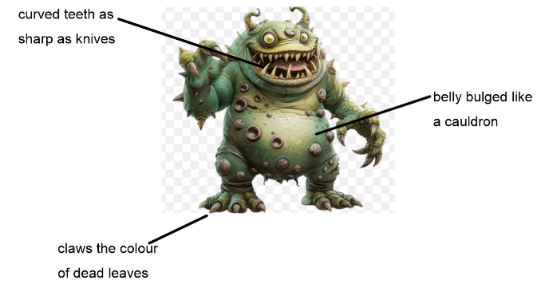
As part of our story writing based on The Magic Paintbrush next week, you will need a goodie character. The goodie will get the magic object just like Shen did in our story.
Your challenge is to design a goodie for your story. You CANNOT use a character that already exists but you could make them a type of character that exists – eg a normal person, a princess, a prince etc. You can even be the main character if you wish!
Draw a picture of your main character and label it with some description that you could use in your story.

