
Trull CE VA Primary School

Behaviour and Relationship

Policy
I have come that they may have life, and have it to the full. John 10:10
Date policy last reviewed: | January 2026

Signed by:
Luke Bottomley | Headteacher | Date: | January 2026
Ryzsard Rusinek | Chair of governors | Date: | January 2026

Trull CE VA Primary School is committed to safeguarding and promoting the welfare of children and young people and expects all staff and volunteers to share this commitment.
Contents:
Statement of intent
- Legal framework
- Roles and responsibilities
- Definitions
- Staff induction, development and support
- Social, emotional and mental health (SEMH) needs
- Managing behaviour
- Prevention strategies, interventions, and sanctions for unacceptable behaviour
- Sexual abuse and discrimination
- Prohibited items, searching pupils and confiscation
- Effective classroom management
- Behaviour outside of school premises
- Data collection and behaviour evaluation
- Monitoring and review
Appendices
- Graduated response
- Reflection sheet KS1
- Reflection sheet KS2
- Three Way Agreement
- Safe IT Equipment Usage Policy

Statement of intent
We, as a School, value every member of our community as a unique child of God and seek to demonstrate His love through our words and actions and this underpins the practice and procedures outlined in this policy.
Our mission statement reads: We at Trull Church of England Voluntary Aided Primary School strive for excellence. We seek to help children achieve their full potential, by encouraging a love of learning and the development of self-esteem in a safe, secure and caring environment. As a Church School we aim to develop Christian values and foster a kind and caring attitude towards other people and respect for their beliefs.

“I have come that they may have life, and have it to the full”
John 10:10
Trull Church of England VA Primary School believes that, in order to facilitate teaching and learning, acceptable behaviour must be demonstrated in all aspects of school life. The school is committed to:
- Promoting desired behaviour.
- Promoting self-esteem, self-discipline, proper regard for authority, and positive relationships based on mutual respect.
- Ensuring equality and fair treatment for all.
- Praising and rewarding good behaviour.
- Challenging and disciplining misbehaviour.
- Providing a safe environment free from disruption, violence, discrimination, bullying and any form of harassment.
- Encouraging positive relationships with parents.
- Developing positive relationships with pupils to enable early intervention.
- A shared approach which involves pupils in the implementation of the school’s policy and associated procedures.
- Promoting a culture of praise and encouragement in which all pupils can achieve.
Reasonable and proportionate sanctions will be used where a pupil’s behaviour falls below the standard that is expected, alongside support to prevent recurring misbehaviour.
The school acknowledges that behaviour can sometimes be the result of educational needs, mental health issues, or other needs or vulnerabilities, and will address these needs via an individualised graduated response.
To help reduce the likelihood of behavioural issues related to social, emotional or mental health (SEMH), the school will aim to create a safe and calm environment in which positive mental health and wellbeing are promoted and pupils are taught to be resilient. The school will aim to promote resilience as part of a whole-school approach using the following methods:
- Culture, ethos and environment – the health and wellbeing of pupils and staff is promoted through the informal curriculum, including leadership practice, policies, values and attitudes, alongside the social and physical environment
- Teaching – the curriculum is used to develop pupils’ knowledge about health and wellbeing
- Community engagement – the school proactively engages with parents, outside agencies and the wider community to promote consistent support for pupils’ health and wellbeing
All staff will be made aware of how potentially traumatic adverse childhood experiences, including abuse and neglect, can impact on a pupil’s mental health, behaviour, and education. Where vulnerable pupils or groups are identified, provision will be made to support and promote their positive mental health. The school’s Social, Emotional and Mental Health (SEMH) Policy outlines the specific procedures that will be used to assess these pupils for any SEMH-related difficulties that could affect their behaviour.

Legal framework
This policy has due regard to all relevant legislation and statutory guidance including, but not limited to, the following:
- Education Act 1996
- Education Act 2002
- Equality Act 2010
- Education and Inspections Act 2006
- Health Act 2006
- Voyeurism (Offences) Act 2019
- The School Information (England) Regulations 2008
- DfE (2022) ‘Behaviour in schools: advice for headteachers and school staff’
- DfE (2025) ‘Keeping children safe in education 2022’
- DfE (2021) ‘Sexual violence and sexual harassment between children in schools and colleges’
- DfE (2018) ‘Mental health and behaviour in schools’
- DfE (2015) ‘Special educational needs and disability code of practice: 0 to 25 years’
- DfE (2013) ‘Use of reasonable force’
- DfE (2022) ‘Searching, screening and confiscation: advice for schools’
- DfE (2023) ‘Suspension and Permanent Exclusion from maintained schools, academies and pupil referral units in England, including pupil movement’
This policy operates in conjunction with the following school policies:
- Pupil Code of Conduct
- Social, Emotional and Mental Health (SEMH) Policy
- Complaints Procedures Policy
- Special Educational Needs and Disabilities (SEND) Policy
- Suspension and Exclusion Policy
- Physical Intervention Policy
- Child-on-child Abuse Policy
- Child Protection and Safeguarding Policy
- Smoke-free Policy
- Pupil Drug and Alcohol Policy
- Searching, Screening and Confiscation Policy
- Anti-bullying Policy

Roles and responsibilities
The governing board will have overall responsibility for:
- Making a statement of behaviour principles and providing guidance for the headteacher on promoting good behaviour where appropriate.
- Ensuring that this policy, as written, does not discriminate on any grounds, including, but not limited to, age, disability, gender reassignment, gender identity, marriage and civil partnership, race, religion or belief, sex and sexual orientation.
- Promoting a whole-school culture where calm, dignity and structure encompass every space and activity.
- Handling complaints regarding this policy, as outlined in the school’s Complaints Procedures Policy.
- Ensuring this policy is published on the school website.
The headteacher will be responsible for:
- The monitoring and implementation of this policy and of the behaviour procedures at the school. This includes monitoring the policy’s effectiveness in addressing any SEMH-related drivers of poor behaviour.
- Acting in accordance with the statement of behaviour principles made by the governing board and having any regard to guidance provided by the governing board on promoting good behaviour.
- Establishing high expectations of pupils’ conduct and behaviour, and implementing measures to achieve this.
- Determining the school rules and any disciplinary sanctions for breaking the rules.
- The day-to-day implementation of this policy.
- Publicising this policy in writing to staff, parents and pupils at least once a year.
- Reporting to the governing board on the implementation of this policy, including its effectiveness in addressing any SEMH-related issues that could be driving disruptive behaviour.
The senior mental health lead will be responsible for:
- Overseeing the whole-school approach to mental health, including how this is reflected in this policy, how staff are supported with managing pupils with SEMH-related behavioural difficulties, and how the school engages pupils and parents with regards to the behaviour of pupils with SEMH difficulties.
- Supporting behaviour management in line with the SEMH Policy.
The SENCO will be responsible for:
- Collaborating with the governing board, headteacher, deputy headteacher and the senior mental health lead, as part of the SLT, to determine the strategic development of behaviour and SEMH policies and provisions in the school.
- Undertaking day-to-day responsibilities for the successful operation of the behaviour and SEMH policies to support pupils with SEND, in line with the school’s Special Educational Needs and Disabilities (SEND) Policy.
- Supporting teachers in the further assessment of a pupil’s strengths and areas for improvement and advising on the effective implementation of support.
Teaching staff will be responsible for:
- Planning and reviewing support for pupils with behavioural difficulties in collaboration with parents, the SENCO and, where appropriate, the pupils themselves.
- Aiming to teach all pupils the full curriculum, whatever their prior attainment.
- Planning lessons to address potential areas of difficulty to ensure that there are no barriers to every pupil achieving their full potential, and that every pupil with behavioural difficulties will be able to study the full national curriculum.
- Teaching and modelling expected behaviour and positive relationships, demonstrating good habits.
- Being responsible and accountable for the progress and development of the pupils in their class.
- Not tolerating disruption and taking proportionate action to restore acceptable standards of behaviour.
All members of staff, including teaching and support staff, and volunteers will be responsible for:
- Adhering to this policy and applying it consistently and fairly.
- Supporting pupils in adhering to this policy.
- Promoting a supportive and high-quality learning environment.
- Modelling high levels of behaviour.
- Being aware of the signs of behavioural difficulties.
- Setting high expectations for every pupil.
- Being aware of the needs, outcomes sought, and support provided to any pupils with specific behavioural needs.
- Keeping the relevant figures of authority up-to-date with any changes in behaviour. The relevant figures of authority include:
  - SENCO.
  - Headteacher.
  - Deputy Headteacher
  - Subject leader.
- As authorised by the headteacher, sanctioning pupils who display poor levels of behaviour.
Pupils will be responsible for:
- Their own behaviour both inside school and out in the wider community.
- Reporting any unacceptable behaviour to a member of staff.
Parents will be responsible for:
- Supporting their child in adhering to the school rules and reinforcing this at home.
- Informing the school of any changes in circumstances which may affect their child’s behaviour.

Definitions
For the purposes of this policy, the school will define “serious unacceptable behaviour” as any behaviour which may cause harm to oneself or others, damage the reputation of the school within the wider community, and/or any illegal behaviour. This will include, but is not limited to, the following:
- Discrimination – not giving equal respect to an individual on the basis of age, disability, gender identity, marriage and civil partnership, pregnancy and maternity, race, religion or belief, sex, and sexual orientation
- Harassment – behaviour towards others which is unwanted, offensive and affects the dignity of the individual or group of individuals
- Vexatious behaviour – deliberately acting in a manner so as to cause annoyance or irritation
- Bullying – a type of harassment which involves personal abuse or persistent actions which humiliate, intimidate, frighten or demean the individual being bullied
- Cyberbullying – the use of electronic communication to bully a person, typically by sending messages of an intimidating or threatening nature
- Electronic Device – any device capable of taking photographs/still images; having access to the internet (through WiFi or another network); being able to facilitate communication electronically.
- Possession of legal or illegal drugs, alcohol or tobacco
- Possession of banned items
- Truancy and running away from school
- Refusing to comply with disciplinary sanctions
- Theft
- Verbal abuse, including swearing, racist remarks and threatening language
- Fighting and aggression
- Persistent disobedience or disruptive behaviour
- Extreme behaviour, such as violence and serious vandalism
- Any behaviour that threatens safety or presents a serious danger
- Any behaviour that seriously inhibits the learning of pupils
- Any behaviour that requires the immediate attention of a staff member
For the purposes of this policy, the school will define “low-level unacceptable behaviour” as any behaviour which may disrupt the education of the perpetrator and/or other pupils, including, but not limited to, the following:
- Lateness
- Low-level disruption and talking in class
- Failure to complete classwork
- Rudeness
- Lack of correct equipment
- Refusing to complete homework, incomplete homework, or arriving at school without homework
- Misuse of school electronic devices
- Disruption on public transport
- Use of mobile phones without permission
- Graffiti
“Low-level unacceptable behaviour” may be escalated to “serious unacceptable behaviour”, depending on the severity of the behaviour. Staff will use their professional judgment to differentiate between “low-level” and “serious” behaviour and may seek advice from colleagues if unsure.
Individual children with individual needs will be dealt in a manner appropriate to their needs and may have an individual plan to suit.
- The decision to discipline a pupil is made by a paid member of school staff, or a member of staff authorised to do so by the teacher.
- The decision to discipline a pupil is made on the school premises or whilst the pupil is under the charge of a member of staff – such as during an educational trip or visit.
- The decision to discipline a pupil is reasonable and will not discriminate on any ground (as per the Equality Act, 2010)
- The school will ensure that all discipline is reasonable in all circumstances, and will consider the pupil’s age, religious requirements, SEMH needs, any SEND, and any other contributing factors – for example: bullying, safeguarding or home life issues.

Staff induction, development and support
All new staff will be inducted clearly into the school’s behaviour culture to ensure they understand its rules and routines and how best to support all pupils to participate in creating the culture of the school. Staff will be provided with bespoke training, where necessary, on the needs of pupils at the school to enable behaviour to be managed consistently.
The SLT will consider any appropriate training which is required for staff to meet their duties and functions in accordance with this policy, including on understanding matters which may affect a pupil’s behaviour, e.g. SEND and mental health needs.
Members of staff who have, or are aspiring to have, responsibilities for leading behaviour or supporting pupil wellbeing will be supported to undertake any relevant training or qualifications.
The SLT and the headteacher will review staff training needs annually, and in response to any serious or persistent behaviour issues disrupting the running of the school.

Social, emotional and mental health (SEMH) needs
To help reduce the likelihood of behavioural issues related to SEMH needs, the school will create a safe and calm environment in which positive mental health and wellbeing are promoted and pupils are taught to be resilient. The school will promote resilience as part of a whole-school approach using the following methods:
- Culture, ethos and environment – the health and wellbeing of pupils and staff is promoted through the informal curriculum, including leadership practice, policies, values and attitudes, alongside the social and physical environment
- Teaching – the curriculum is used to develop pupils’ knowledge about health and wellbeing
- Community engagement – the school proactively engages with parents, outside agencies and the wider community to promote consistent support for pupils’ health and wellbeing
All staff will be made aware of how potentially traumatic adverse childhood experiences, including abuse and neglect, can impact on a pupil’s mental health, behaviour, and education. Where vulnerable pupils or groups are identified, provision will be made to support and promote their positive mental health. The school’s SEMH Policy outlines the specific procedures that will be used to assess these pupils for any SEMH-related difficulties that could affect their behaviour.

Managing behaviour
Instances of unacceptable behaviour are taken seriously and dealt with immediately. Staff will respond promptly, predictably and with confidence to maintain a calm, safe learning environment. Staff will consider afterwards how to prevent such behaviour from recurring.
The SENDCo will keep a record of all reported incidents to help identify pupils whose behaviour may indicate potential mental health problems or safeguarding problems. All staff will be alert to changes in a pupil’s behaviour that could indicate they need help or protection. Support, such as targeted discussions with pupils, a phone call with parents, and inquiries into circumstances outside of school by the DSL, will be provided alongside the use of sanctions to prevent the misbehaviour recurring.
After an initial incident of negative behaviour, the following sanctions will be considered, with staff using their professional judgement and experience to determine what is appropriate and reasonable:

Verbal warning given first, then…

Stage One:
All - If behaviour persists after a quiet verbal warning given, move child’s peg (this is a visible warning), no major discussion entered into other than an understanding of why they have moved. There is an expectation that a conversation will occur between the pupil and their teacher as to why their peg has been removed and if any further action is necessary. A conversation may be required between members of staff to discuss this.
KS1- Then, if behaviour continues, a pupil may miss playtime and complete KS1 reflection sheet with support if needed to understand and discuss unacceptable behaviour. (If a child is regularly asked to fill in a reflection sheet, then this will be flagged to the Senior Leadership Team to observe and a discussion to take place. We do not want children to have a ‘reputation’ by their peers as being the naughty child and therefore need to ensure that this is dealt with straight away.
In KS2, if behaviour does not improve, then a pupil may miss playtime and complete KS2 reflection sheet with support if needed to understand and discuss unacceptable behaviour. (If a is child regularly asked to fill in a reflection sheet, then this will be flagged to the Senior Leadership Team to observe and a discussion to take place. Again, we do not want children to have a ‘reputation’ by their peers as being the naughty child and therefore need to ensure that this is dealt with straight away.

There are always opportunities to return a peg when acceptable behaviour resumes; we are always looking for the positive.

Staff should communicate any behaviour that they have found concerning or that they feel has warranted repeated feedback to other relevant team members (teacher to support staff and vice versa). We pride ourselves on working well as a team – communication is key!
Following repeated incidents of unacceptable behaviour however, the following sanctions are implemented:

Stage Two:
- Removal from the class, first to a ‘Buddy Class’ nearby, with some work to complete given by the class teacher and then, if behaviour persists, to the Deputy Headteacher for some time out with work set by class teacher.
- Teacher to talk to parent/carer regarding behaviour of the child at the end of the school day. Deputy Headteacher may also be involved in the conversation with the parent/carer if deemed appropriate.

Stage Three:

Headteacher Intervention
- Headteacher informed of behaviour and a warning is given. Time with the Head to discuss behaviour and dependent on behaviour exhibited, either time out or returned to class.
- Internal exclusion could be given- child is removed from class and works somewhere quiet for a period of time with supervision. Break time given at a different time to other children.
- Individual Behaviour Plan filled in by pupil and SENCo, with parents.
- Counselling re: behaviour issues and support given to the pupil to change behaviour (e.g. target sheet, peer support etc).
- Name entered on CPOMS. Enter date, name, behaviour exhibited, consequence and action.
- If appropriate and possible, the child may need to have their play/lunchtime separately to their peers.
- If a name appears twice within a two-week period, they should automatically move to Stage Three again and behaviour reviewed with SENDCo.
- SENDCo or SLT may request that an ABCC chart(Antecedent, Behaviour, Consequence, Communication) be filled out in order to identify any triggers to negative behaviour. This evidence will then inform future decision making.
- Should repeated negative behaviour occur, a Behaviour Plan will be created with the SENDCo, class teacher, parent and child involved.
- Parent involved from Stage Three.
- Although unacceptable behaviour does not necessarily mean a pupil has SEND, an assessment will be carried out at this stage to determine whether there are any undiagnosed learning or communication difficulties, or mental health issues that may be contributing to the pupil’s behaviour.
- Where a pupil is identified as having SEMH-related difficulties, SEND support will be put in place from the school’s national SEND budget.
- Where SEND is not identified, but the headteacher determines that support is still required for the pupil, an Individual Behavioural Plan will be created to outline the necessary provisions in place.

Stage Four:

Suspension/Exclusion
Parents informed by official letter (as set out by the LA exclusions process )
Usually a graduated response: one day; three day, five day or permanent

Prevention strategies, positive behaviour strategies, intervention, and sanctions for unacceptable behaviour
This section outlines the school’s strategies for preventing unacceptable behaviour, minimising the severity of incidents, and using sanctions effectively and appropriately to improve pupils’ behaviour in the future.
Positive teacher-pupil relationships
Positive teacher-pupil relationships are key to combatting unacceptable behaviour. The school focusses heavily on forming these relationships to allow teachers to understand their pupils and create a strong foundation from which behavioural change can take place.

POSITIVE BEHAVIOUR

Secret Student
In KS2 each class will have a daily ‘secret student’. This student will be known to the adults but not the children. His/her behaviour will be commented upon throughout the day. In the event of good behaviour a token will be awarded towards a class treat, agreed in advance by the class together. If it is deemed that one child is disrupting the secret student award that child can miss out on the class treat/reward and will spend that reward time in another class.
House Points
Teachers and support staff are encouraged to award house points to children who demonstrate excellent or markedly improved behaviour, for good effort and attainment, and for demonstrating school values. House Points will be collected weekly, and the House Trophy will be presented to the winning house captains on a Friday in Celebration Assembly/Collective Worship.
Certificates
Staff are encouraged to give out Values Certificates to children who demonstrate the school values: friendship, forgiveness, respect. The certificates can be found outside of the Headteacher’s office and should be completed and placed in the wooden box in the hall.
Headteacher’s Awards can also be given out for excellent pieces of work, for milestones outside of school, or for other suitable reasons. These awards and written by the Headteacher and the nomination should be made before the morning of Friday’s assembly.

5-to-1 Strategy
For every one complaint or criticism to a child, staff should endeavour to provide the child with five positive interactions – including but not limited to: compliments, approval statements, positive comments, non-verbal gestures, empathy statements and affirmations.
Positive Feedback
Whilst there is an expectation that negative behaviour is reported to parents/carers, staff are encouraged to communicate positive behaviour as well. This can be discrete (using a note in a book bag for example) or speaking to a parent/carer on the playground before or after school.

Other Strategies
Class teachers are encouraged to create their own ‘positive strategies’ that embrace the school’s values and reward children individually, in groups or as a whole class for desired behaviour. These may include ‘class nuggets’ or ‘Wow’ cards to communicate good behaviour to the class or community.
Privilege Play
During a normal week, teaching staff will select up to five children per class who have demonstrated school values and shown a high level of behaviour throughout the school days. The children selected will be told the reasons they have been selected and will be sent for an extra break time at 2:45 in the afternoon with a member of the Headteacher/SLT.

Fresh Start Policy

Fresh Start Policy
- Children always start the day with their pegs back on the sunshine/smiley face
- During each school day, children will have the opportunity to have their peg moved back on to the sunshine/smiley face by demonstrating expected behaviours both in and out of the classroom.

De-escalation strategies
Where negative behaviour is present, staff members will implement de-escalation strategies to diffuse the situation. This includes:
Appearing calm and using a modulated, low tone of voice
Using simple, direct language.
Avoiding being defensive, e.g. if comments or insults are directed at the staff member.
Providing adequate personal space and not blocking a pupil’s escape route.
Showing open, accepting body language, e.g. not standing with their arms crossed.
Reassuring the pupil and creating an outcome goal.
Identifying any points of agreement to build a rapport.
Offering the pupil a face-saving route out of confrontation, e.g. that if they stop the behaviour, then the consequences will be lessened.
Rephrasing requests made up of negative words with positive phrases, e.g. “if you don’t return to your seat, I won’t help you with your work” becomes “if you return to your seat, I can help you with your work”.

Physical intervention
In line with the school’s Positive Handling Policy, trained members of staff have the legal right to use reasonable force to prevent pupils from committing an offence, injuring themselves or others, or damaging school property, and to maintain good order and discipline in the classroom.
Physical restraint will only be used as a last resort and as a method of restraint. Staff members will use their professional judgement of the incident to decide whether physical intervention is necessary. The situations in which physical restraint may be appropriate are detailed in the Positive Handling Policy.
Wherever possible, staff will ensure that a second member of staff is present to witness the physical intervention used. After an instance of physical intervention, the pupil will be immediately taken to the headteacher and the pupil’s parent will be contacted – parents may be asked to collect the pupil and take them home for the rest of the day.
Any violent or threatening behaviour will not be tolerated by the school and may result in a fixed-term exclusion in the first instance. It is at the discretion of the headteacher as to what behaviour constitutes for an exclusion.
When using reasonable force in response to risks presented by incidents involving pupils with SEND or medical conditions, the school will recognise and consider the vulnerability of these groups. Behaviour will always be considered in relation to a pupil’s SEND. If it is deemed that a pupil’s SEND has contributed to their misbehaviour, the school will consider whether it is appropriate and lawful to sanction the pupil.
Where a pupil is identified as having SEND, the graduate approach will be used to assess, plan, deliver and review the impact of support being provided.
Internal exclusion
The school may decide to move pupils to a separate room away from other pupils for a limited period – these are known as internal exclusion.
The school will only enforce and internal exclusion when absolutely necessary. The school will ensure that pupils’ health and safety is not compromised during their time in exclusion, and that any additional requirements, such as SEND needs, are met.
The amount of time that a pupil spends in an internal exclusion will be up to the school to decide. This could be for more than one school day. The school will ensure that the pupil is not kept in isolation any longer than necessary.
The staff member in charge and supervising the pupil will decide what the pupil may and may not do during their time spent in isolation. The headteacher will request that the pupil’s class teachers set them appropriate work to complete.
Pupils are permitted to eat during the allocated times of the school day and may use the toilet as required.
Detentions
The school will make it clear to parents and pupils that they are able to use detention as a sanction, both during and outside of school hours.
All teachers at the school can impose detention on a pupil, unless the headteacher decides to withdraw this power from any teacher.
The following indicate the times during which detention can be issued outside of school hours:
- Any school day where the pupil is not authorised to be absent
- During weekends, except for any weekend preceding or following a half-term
- Any non-teaching day, e.g. INSET days
Parental consent is not required for detentions and, therefore, the school is able to issue detention as a sanction without first notifying the parents of the pupil.
When issuing detentions, members of staff will ensure that they do so reasonably within the given circumstances, and that they consider any additional needs of the pupil. If the detention is during lunchtime, 25 minutes will be allocated to allow the pupil time to eat, drink and use the toilet. When issuing detentions which are set to be outside of school hours, the member of staff doing so will consider:
- Whether the detention is likely to put the pupil at risk.
- Whether the pupil has identified caring responsibilities which would make the detention unreasonable.
- Whether the parents ought to be informed of the detention, e.g. it may not be necessary to do so if the detention is for short period after school and the pupil is able to return home safely.
- Whether suitable transport arrangements are in place between the parents and the pupil. It does not matter whether these transport arrangements are inconvenient to the parents.

Sexual abuse and harassment
The school will promote and enforce a zero-tolerance approach to all forms of sexual abuse and harassment, including sexual harassment, gender-based bullying and sexual violence. The school’s procedures for handling child-on-child sexual abuse and harassment are detailed in the Child-on-child Abuse Policy.
The school will respond promptly and appropriately to any sexual harassment complaints in line with the Child Protection and Safeguarding Policy; appropriate steps will be taken to stop the harassment and prevent any reoccurrence. Disciplinary sanctions for incidents of sexual harassment will be determined based on the nature of the case, the ages of those involved and any previous related incidents.
Where the school is responding to a report of sexual violence, the school will take immediate steps to ensure the victim and other pupils are protected. The DSL will work closely with the police, and any other agencies as required, to ensure that any action the school takes, e.g. disciplinary sanctions, will not jeopardise the police investigation.

Prohibited items, searching pupils and confiscation
Headteachers and staff authorised by them will have a statutory power to search pupils or their possessions, without consent, where they have reasonable grounds for suspecting that the pupil may have a prohibited item. Authorised members of staff will be permitted to use reasonable force when conducting a search without consent for the prohibited items listed below, in line with the school’s Physical Intervention Policy. The prohibited items where reasonable force may be used are:
- Knives and weapons.
- Alcohol.
- Illegal drugs.
- Stolen items.
- Mobile phones
- Any device capable of creating an image – Smart Watch, Digital Camera, Hot Paper Camera, tablet etc.
- Tobacco and cigarette papers.
- Fireworks.
- Pornographic images.
- Any article that the member of staff reasonably suspects has been, or is likely to be, used:
  - To commit an offence; or
  - To cause personal injury to any person, including the pupil themselves; or
  - To damage the property of any person, including the pupil themselves.
All members of staff can use their power to search without consent for any of the items listed above. Staff will follow the provisions outlined in the school’s Searching, Screening and Confiscation Policy when conducting searches and confiscating items.

Effective classroom management
Well-managed classrooms are paramount to preventing disruptive and unacceptable behaviour. Effective classroom management will allow staff to:
- Start the year with clear sets of rules and routines that are understood by all pupils.
- Establish agreed rewards and positive reinforcements.
- Establish sanctions for misbehaviour.
- Establish clear responses for handling behavioural problems.
- Encourage respect and development of positive relationships.
- Make effective use of the physical space available.
- Have well-planned lessons with a range of activities to keep pupils stimulated.
Subject to reasonable adjustments, e.g. those made for pupils whose SEND may affect their behaviour, pupils will be expected to follow the school Pupil Code of Conduct, which requires pupils to:
- Conduct themselves around the school premises in a safe, sensible and respectful manner.
- Arrive to lessons on time and fully prepared.
- Follow reasonable instructions given by staff.
- Behave in a reasonable and polite manner towards all staff and pupils.
- Show respect for the opinions and beliefs of others.
- Complete classwork as requested.
- Hand in homework at the time requested.
- Report unacceptable behaviour.
- Show respect for the school environment.
Classroom rules and routines
The school will have an established set of clear, comprehensive and enforceable classroom rules which define what is acceptable behaviour and what the consequences are if rules are not adhered to. Attention is given to how rules are worded, such as the use of positive language rather than negative, e.g. “act respectfully towards your peers and teachers”, rather than “do not act disrespectfully towards your peers and teachers”.
The school will also have an established set of classroom routines to help pupils work well, in the understanding that behavioural problems can arise due to the lack of a consistent routine. This includes teachers ensuring that before lessons begin, they have the full attention of all pupils, then explaining the task clearly so all pupils understand what they are supposed to be doing.
The headteacher will ensure all teachers understand classroom rules and routines and how to enforce them, including any sanctions for not following the rules.
Teachers will support pupils to understand and follow classroom rules and routines. Teachers will inform pupils of classroom rules and routines at the beginning of the academic year and revisit these daily. Where appropriate, teachers will explain the rationale behind the rules and routines to help pupils understand why they are needed, and will model rules and routines to ensure pupils understand them. Teachers will also explain clearly to pupils what will happen if they breach any classroom rules to ensure pupils are aware of the sanctions that may be imposed.
To support pupils’ continued awareness and understanding of classroom rules and routines, teachers will reinforce them in a range of ways, e.g. placing posters of the rules on classroom walls and providing regular verbal reminders of the routines. Teachers will also ensure that classroom rules and routines remain consistent and are practised throughout the year to create a more productive and enjoyable environment.
At the beginning of the school year, once the classroom rules have been devised, pupils will be provided with a Three-Way Agreement which they are required to read and sign. All rules outlined in the Three-Way Agreement are applicable to pupils’ behaviour elsewhere on the school premises and outside of the school – teachers will ensure that pupils understand this.
For younger pupils, parents will read the Three-Way Agreement with their child and sign it on their behalf.
The classroom environment
The school understands that a well-structured classroom environment is paramount to preventing poor behaviour. This includes the teacher positioning themselves effectively within the classroom, e.g. wherever possible, teachers avoid standing with their backs to pupils and ensure they have full view of the room at all times.
Teachers will employ strategic seating arrangements to prevent poor behaviour and enable it to be noticed early, such as:
- Seating those who frequently model poor behaviour closest to, and facing, the teacher.
- Seating those who frequently model poor behaviour away from each other.
- Ensuring the teacher can see pupils’ faces, that pupils can see one another, and that they can see the board.
- Ensuring the teacher can move around the room so that behaviour can be monitored effectively.
Praise and rewards
The school will recognise that praise is key to making pupils feel valued and ensuring that their work and efforts are celebrated. When giving praise, teachers will ensure:
- They define the behaviour that is being rewarded.
- The praise is given immediately following the desired behaviour.
- The way in which the praise is given is varied.
- Praise is related to effort, rather than only to work produced.
- Perseverance and independence are encouraged.
- Praise is only given when a pupil’s efforts, work or behaviour need to be recognised, rather than continuously without reason.
- The praise given is always sincere and is not followed with immediate criticism.
Whilst it is important to receive praise from teachers, the school understands that peer praise is also effective for creating a positive, fun and supportive environment. Teachers will encourage pupils to praise one another, and praise another pupil to the teacher, if they see them modelling good behaviour.
As with praise, the school understands that providing rewards after certain behaviour means that pupils are more likely to model the same behaviour again. For rewards to be effective, the school recognises that they need to be:
- Immediate – immediately rewarded following good behaviour.
- Consistent – consistently rewarded to maintain the behaviour.
- Achievable – keeping rewards achievable to maintain attention and motivation.
- Fair – making sure all pupils are fairly rewarded.
Rewards for good behaviour will include, but are not limited to:
- Verbal praise
- House Points
- Headteacher Awards/certificates
- Positions of responsibility, e.g. class monitors or positions in Year 6
- Secret Student Treat – this is a whole class team effort award in KS2
- Nuggets in the Jar for KS1 - a whole class team effort and a treat when the jar is full.

Behaviour outside of school premises
Pupils at the school must agree to represent the school in a positive manner. The guidance laid out in the Pupil Code of Conduct will apply both inside school and out in the wider community, particularly if the pupil is dressed in school uniform.
Staff can discipline pupils for misbehaviour outside of the school premises, including conduct online, when the pupil is:
- Wearing school uniform.
- Travelling to or from school.
- Taking part in any school-related activity.
- In any way identifiable as being a pupil at the school.
Staff may also discipline pupils for misbehaviour outside the school premises, including conduct online, that:
- Could negatively affect the reputation of the school.
- Could pose a threat to another pupil, a member of staff at the school, or a member of the public.
- Could have repercussions for the orderly running of the school.
Any bullying witnessed outside of the school premises and reported to the school will be dealt with in accordance with the Anti-bullying Policy.
Concerns regarding the online conduct of any member of the school community on social media are reported to the DSL/Headteacher and managed in accordance with the relevant policy, e.g. Anti-Bullying Policy, Staff Code of Conduct and Behavioural Policy. The Online Safety Policy outlines age-appropriate applications, websites and social media, as well as the Three-Way Agreement.
The school will impose the same sanctions for bullying incidents and non-criminal misbehaviour witnessed or reported outside of the school premises as would be imposed for the same behaviour conducted on school premises. In all cases of unacceptable behaviour outside of the school premises, staff will only impose sanctions once the pupil has returned to the school premises or when under the supervision of a member of staff.
Complaints from members of the public about the behaviour of pupils from the school are taken very seriously and will be dealt with in accordance with the Complaints Procedures Policy.

Data collection and behaviour evaluation
The school will collect data from the following sources:
- Behaviour incident data, including on removal from the classroom
- Attendance, permanent exclusion and suspension data
- CPOMs – safeguarding log
- Use of pupil support units, off-site directions and managed moves
- Incidents of searching, screening and confiscation
- ABC Forms – completed and collated by SENDCo
- Anonymous surveys for staff, pupils, governors, and other stakeholders on their perceptions and experiences of the school behaviour culture
The data will be monitored and objectively analysed by the headteacher and the SLT. Attempts will be made to identify possible factors contributing to the behaviour, any system problems or inadequacies with existing support. The data will also be analysed considering the protected characteristics under the Equality Act 2010 to inform school policies and practice.

Monitoring and review
This policy will be reviewed by the headteacher and senior mental health lead on an annual basis; they will make any necessary changes and communicate these to all members of staff and relevant stakeholders.
This policy will be made available for Ofsted inspections and reviews by the lead inspector, upon request.
The next scheduled review date for this policy is January 2027.

GRADUATED DISCIPLINE POLICY
Inevitably, there are times when pupils display inappropriate or unacceptable behaviour. The following outlines the stages of sanctions imposed when a child displays such behaviours. It is our policy that every opportunity should be given for the child to turn their bad behaviour around and choose to do the right thing. If there is serious misconduct, a pupil may miss stages e.g. move straight to Stage Three- see Challenging behaviour section 9
Stage one
- Verbal warning given first. If behaviour continues …

- Peg is taken off the smiley face and put on teacher’s desk in a pot.
Child can earn the return of the peg onto the smiley face by showing acceptable and improved behaviour.
If negative/inappropriate behaviour continues
3. Consequence is given of missing playtime and completing appropriate Key Stage reflection sheet with the help of an adult who will discuss the behaviour seen. Sheet to be handed in to Headteacher.
Stage two
If poor behaviour continues…
- FIRST OFFENCE: Child is sent to a ‘Buddy Class’ to do work set by own class teacher for a short period of time. Spoken to by class teacher upon return. At the end of the day the teacher speaks with the child’s parent, explains events, with child present, and asks for support at home.
- SECOND OFFENCE Sent to Deputy Head or SENCO with work set by the class teacher. At the end of the day the teacher speaks with the child’s parent, explains events, with child present, and asks for support at home.

Stage Three
after all other stages have been met or serious incident requires Head teacher intervention straight away
- Sent to Head Teacher – Headteacher informed of behaviour and a warning is given. Time with the Head to discuss behaviour and dependent on behaviour exhibited, either time out or returned to class.
- Parents informed to discuss ways of working together to guide the child to improve their behaviour or attitude to work and if require devising individual behaviour programmes (IBP) This will be logged with the SENDCo who will review the behaviours for any patterns.
- If negative behaviour continues-an Internal Exclusion will be used- the child works away from the class, work to be set by the teacher, Child has a break but at a separate time to the rest of the Key Stage/class.

Stage Four
Final consequence
If negative behaviour still continues and after discussion with parents and County, a fixed term Suspension may be given and then finally an exclusion in line with DfE and School exclusion policy.


Trull CE VA Primary School
Behaviour Reflection Sheet
KEY STAGE 1/EYFS
Please give this form to the SENDCo/Head upon completion)
Name: |  |  | Date and Time:
Class: |  | Name of the adult supporting the child
Please draw a picture in the space below to show what happened.
(Please can an adult scribe for the child to explain what happened.)

Trull CE VA Primary School
Behaviour Reflection Sheet
KEY STAGE 2
( Please give this form to the SENDCo/Head upon completion)
Name: |  | Date:
Class: |  | Time:
What happened?
Who was involved?
How did this make you feel?
Did the way you were feeling affect your behaviour? How?
How do you think the other people involved felt? How do you know?
What should happen next?
Signed……………………………………….

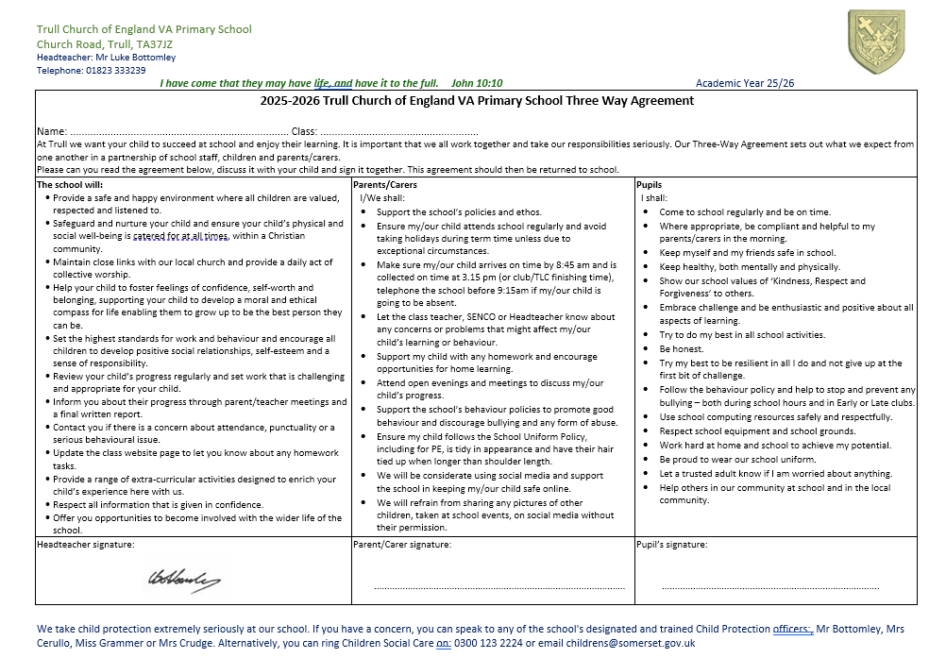

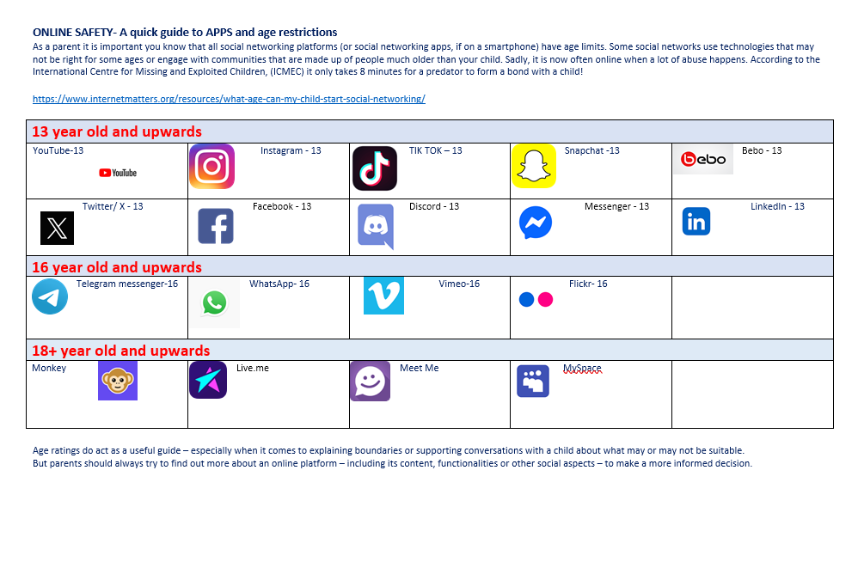

Key Stage 2 Safe Device Usage Policy
Class: ________________________
This agreement is to ensure that children at Trull Primary School know how they are expected to use technology both on and offline safely, respectfully and responsibly during their time at school, Early and Late clubs.
Education and eSafety:
- Pupils will think critically about what they see and not believe everything that they read online.
- Pupils will not share their passwords or log onto a school device using someone else’s details.
- Pupils will not share information, images or videos unrelated to their learning.
- The devices are to be used for the purpose of the lesson or activity (with a member of staff’s consent and supervision).
Digital Behaviour:
- Any communication should be respectful and polite – as if you were communicating in person. Remember, anything you type and send can be seen by your classmates and school staff.
- Pupils must not photograph or record (audio or visually) any member of the school community without the explicit consent of a member of staff.
- This agreement is part of the wider school behaviour policy.
Using Devices:
- Any mobile phones brought to school must be handed into the school office at the start and end of the day.
- The school devices must be looked after. The iPads must remain in their cases.
- Pupils will not sign into other WiFi signals or use Bluetooth devices without permission.
- Pupils will not alter settings or permissions on the devices.
Signed:

